
Documentation & Submission
Kalaivanan Murugan


1. Dataset Used
The dataset contains international e-commerce sales information with fields such as:
- Country
- Region
- Category
- Sub-Category
- Sales
- Quantity
- Discount
- Profit
- Order Priority

2. Data Cleaning Steps
• Converted Sales, Quantity, Discount, and Profit to numeric formats.
• Standardized text fields (Country, Region, Category, Sub-Category, Order Priority).
• Corrected inconsistencies (e.g., category name corrections).
• Checked for missing values and removed duplicates.
• Ensured Quantity is whole numbers and Discount is between 0–1.
• Verified and corrected outlier profit values.
• Checked All data and Format
• If Missing Values Found Replace With Suitable Values Using Responsible Functions

3. Formulas / Calculations Used

- A variety of standard and conditional formulas were used to perform calculations, summarize data, and extract meaningful information.
- SUM, AVERAGE, LEFT, RIGHT, IF, NESTEDIF, AVERAGEIF, COUNTIF, COUNTBLANK

4. Key Insights
• Technology and Office Supplies generate the highest revenue.
• Western Europe, East Asia, and Western US have strong sales performance.
• Higher discounts reduce profit margin.
• 'Critical' priority orders dominate the dataset.
• Phones and Accessories are the most sold sub-categories.

5. Dashboard Screenshot
Below is the inserted dashboard screenshot:

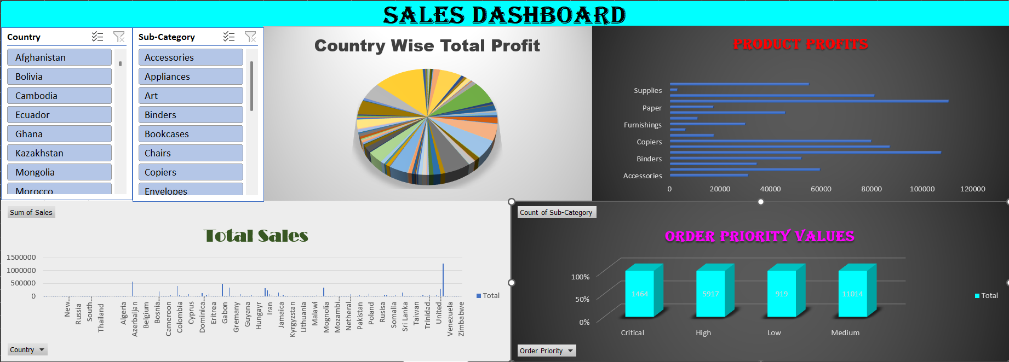

6. attachments
- Excel File Link
- Dashboard Screenshot pdf

